BajaSAE Frame Design Pre-Check

Roll Cage Geometry Drawings

School Name:
Team Name:

Instructions
On the following pages, insert engineering drawings (CAD renderings, etc.) of your frame in the following standard views:
- Front
- Side
- Top
- Isometric
The drawings should note the following items:
- Callouts indicating the material that is used in the frame
- The major dimensions and angles required to meet the frame rules in B8.3. This includes the driver’s seat bottom so that the SIM height, the RRH width, and the RHO LC (point C) can clearly be defined.

Submitting this Document
When you are ready to submit this document, print/convert it to PDF format; the maximum acceptable file size is 10 MB.

Log on to www.bajasae.net and click My Team Document Submissions. There will be a slot for “Frame Design Pre-Check- Roll Cage Geometry Drawings” for each competition. If your frame will not (and does not) change between competitions, you may upload this exact same document for each competition. If your design changes significantly, you should submit an updated document. You can always submit an updated version of the document before the due date listed on the site.

The National Tech Inspector frame specialists will review your submission and mark it as “Accepted” or “Rejected” on CdsWeb. Questions or feedback will be provided for rejected submissions.

Front View

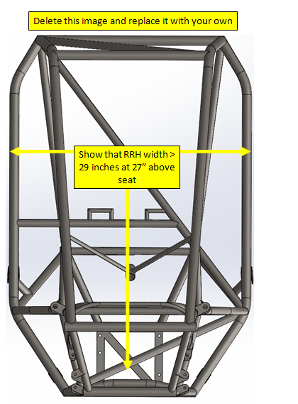

Side View

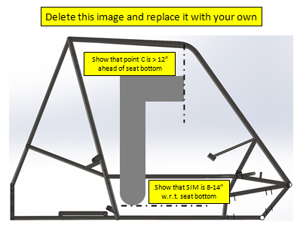

Top View

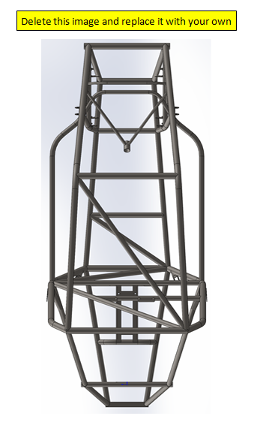

Isometric View

