BajaSAE Frame Design Pre-Check

Roll Cage Documentation

School Name:
Team Name:

Instructions
On the following pages, insert the following information as a screenshot, photo, or scanned image. Add as many pages are necessary; please make sure that your information is CLEAR and READABLE!

- Roll Cage Specification Sheet
  - You do NOT need to specify the car number or competitions on this pre-check form
  - You do NOT need signatures on this pre-check form
  - The above two items ARE needed on the paper copy that you bring to each competition!
- Frame Material Documentation
  - Invoice of roll cage material
  - Material Test of Certification
  - Any Required Calculation per rule B8.3.12

Submitting this Document
When you are ready to submit this document, print/convert it to PDF format; the maximum acceptable file size is 10 MB.

Log on to www.bajasae.net and click My Team Document Submissions. There will be a slot for “Frame Design Pre-Check- Roll Cage Documentation” for each competition. If your frame will not (and does not) change between competitions, you may upload this exact same document for each competition. If your design changes significantly, you should submit an updated document. You can always submit an updated version of the document before the due date listed on the site.

The National Tech Inspector frame specialists will review your submission and mark it as “Accepted” or “Rejected” on CdsWeb. Questions or feedback will be provided for rejected submissions.

Roll Cage Spec Sheet

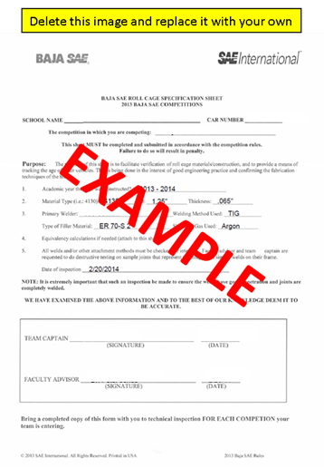

Material Invoice(s)

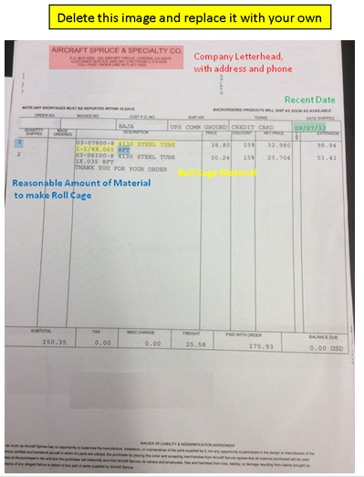

Material Certification(s)

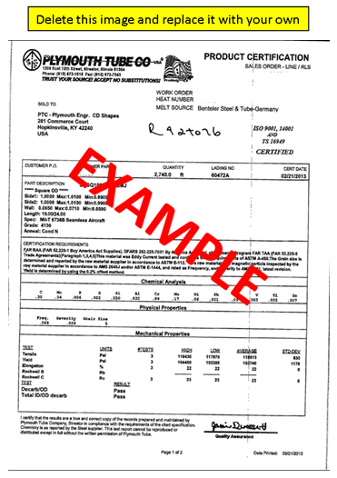

Supporting Calculations (If applicable)
